Project Report

Movie Recommendation System – Using KNN

Course: CIS 585 - 002, Winter 2024
By: Nayan Patel
UoM ID: 27900573



Table of Contents

Table of Contents 2
1 Purpose 3
2 Scope 3
3 Overview 3
3.1 Project Objective 3
3.2 Background 3
4 System Introduction 3
4.1 Recommendation System – Overview 3
4.2 K-Nearest Neighbors (KNN) Algorithm Overview 4
5 Software Design & Implementation 5
5.1 Architectural Overview 5
5.2 Implementation Details 6
5.2.1 SW Tools Used 6
5.2.2 Implementation Steps 7
6 Result Analysis 11
7 Challenges 13
8 Further Improvement Ideas 13
9 Resources and References 14

Purpose
The document is the project report for the academic project that is part of course CIS 585, Winter 2024 term at University of Michigan-Dearborn.

Scope
This project report provides the technical details of the architecture and implementation of “Movie Recommendation System – Using KNN”. It covers the overview of the project, system description, SW architecture and design, challenges faced during the project and references.

Overview

Project Objective
The main goal of the project is to design a movie recommendation system that builds a model using a large movie database as input to the K-Nearest Neighbors algorithm. This model can be further used to take one or more movies as input and then outputs a list of recommended movies.

Background
Online movie streaming apps like Netflix, Amazon Prime, Hulu, Disney etc. have brought choices of thousands of movies and TV series at your fingertip. More choices when bring enjoyment and comfort to our lives, some time may make you confused and frustrated. To make our lives easy in the world of infinite movie choices, a movie recommendation system is proposed in this project.

System Introduction

Recommendation System – Overview
There are three types of recommendation system:
- Content Based Recommendation System: This kind of system is built based on the description of the item and nothing to do with the user input. For example, the description of the movie, actors, director, genre etc. are the contents in the dataset that are used to build a content-based recommendation system.
- Collaborative Based Recommendation System: This method is usually based on collecting and analyzing the data that’s built on user’s input or preferences or both and then predicting the user likings.
- Hybrid Recommendation System: Hybrid system as the name suggests, is a combination of content based and collaborative systems. In this kind of system, the content based and collaborative based predictions are processed separately at first and at last combined them to create a final recommendation. Other type of hybrid systems include dataset that are description of the item as well as user’s preferences.
In this project, we have exercised content-based recommendation system for predicting movies. K-Nearest Neighbors (KNN) algorithm has been used to find the best matched movies.

K-Nearest Neighbors (KNN) Algorithm Overview
k-Nearest Neighbors (KNN) algorithm is a machine learning, supervised algorithm. Here’s a simple explanation of how the KNN works:
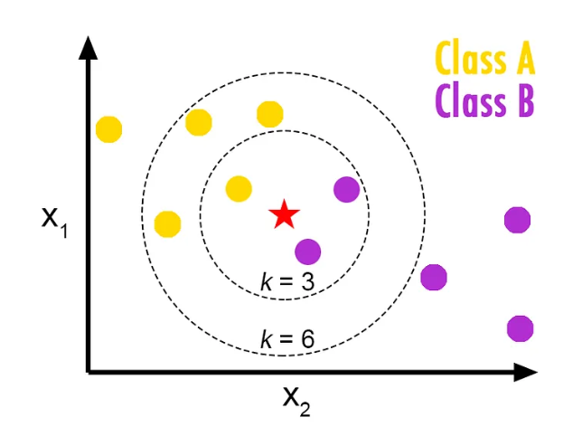
Courtsey: Reference 9
Here there are two classes: Class A that belongs to the Yellow family and Class B that belongs to the Purple family. With trained KNN model for K=3, it can reach to 3 neighbors and with K=6, 6 neighbors can be reached which are nearest. When K=3, 2 Class B items are reached and 1 Class A item is reached but when K=6, same 2 Class B items are reached but now, total 4 Class A items are reached. So for K=3, the majority votes are for Class B and when you increase K=6, the majority votes are for Class A and whichever Class has a majority votes that wins and is sent out as the predicted value.
The KNN algorithm has two variants: Classification and Regression. Being a supervised algorithm, it uses labeled data where the data is split into two categories:
- A target (dependent) variable: The variable that you want to predict
- Explanatory (independent) variables: The variables that are known and available.
The KNN is a non-linear method that is grouped into two types:
- Classification: This type of KNN method is used when the target variable is of categorical type.
- Regression: When the target variable is of numeric type, this method is used.
In this experiment, since our data is categorical (i.e., genre, actor, director, language, writer etc.), KNN Classification method has been used in the experiment in this project.
There are three different KNN algorithms that are the most popular and widely used:
- Kd Tree
- Ball Tree
- Brute Force
For the comparison, all three as well as auto setting of the code library have been tried out.

Software Design & Implementation

Architectural Overview
The SW architecture of the implementation of movie recommendation system is depicted in the following diagram. Section 5.2.2 (Implementation Details) explain the details about each of the blocks in this diagram.

Implementation Details

SW Tools Used
Language: Python v3.10
Libraries Used: Following Python libraries were used:
- pandas
- numpy
- seaborn
- matplotlib (modules used: pyplot)
- sklearn (modules used: pipeline, preprocessing, model_selection, compose, neighbors, metrics, impute)
- tkinter
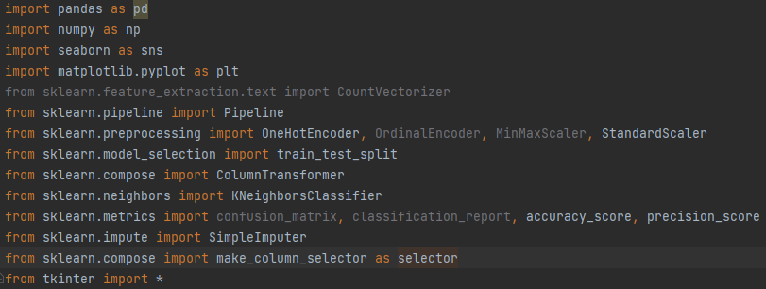
Editor: Pycharm 2022.2.2 (Community Edition)
Hardware Platform: Windows 10 Machine with CPU@2.70 GHz, 16.0 GB RAM and 1TB SDD

Implementation Steps
The whole implementation of the movie recommendation system is divided into four major steps:
- Extracting and Cleaning & Organizing Data:
  - Extracting Data: In this step, data is extracted from the “Movie_Data.csv”. The extracted data is preliminarily stored in a dataframe.
  - Cleaning & Organizing Data: The data contains following categories:
    - Title
    - Genre
    - Tags
    - Languages
    - Director
    - Write
    - Actors
    - View Rating
    - Awards Received
    - Awards Nominated For
    - Boxoffice
    - IMDb Score
    - IMDb Votes
    - Netflix Link
    - Summary
    - Image
For the sake of the modeling, we do not need many categories which have no meaning or relevance with the target variable, so the data of following categories was removed:
    - View Rating
    - Awards Received
    - Awards Nominated For
    - Boxoffice
    - Netflix Link
    - Summary
    - Image
Also, there are several columns in the dataset where the cell values were missing, so the python dataframe automatically fills out those cells with NaN (not a number). This does not work for the KNN classification library that has been used and hence, those empty cells were replaced with dummy text and dummy numeric values.
- Exploratory Data Analysis: Following analysis was performed in the dataset:
- Average IMDb Score and Votes of the movie rated by the users. Surprisingly, the average score and votes of the movies rated by the users are quite high.
- Histogram showing the frequency distribution of the IMDb Score. The score shows that the IMDb score is not uniformly distributed and not balanced.
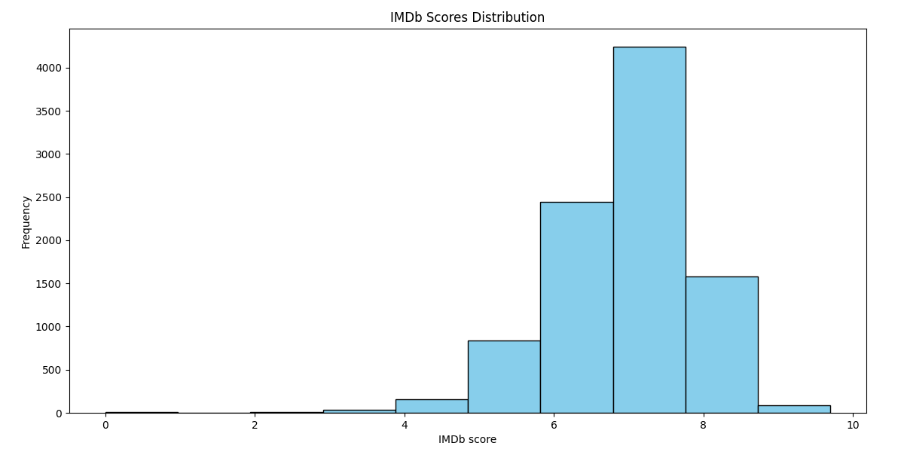
- Histogram showing the frequency distribution of the IMDb Votes. The score shows that the IMDb votes are not uniformly distributed and not balanced.

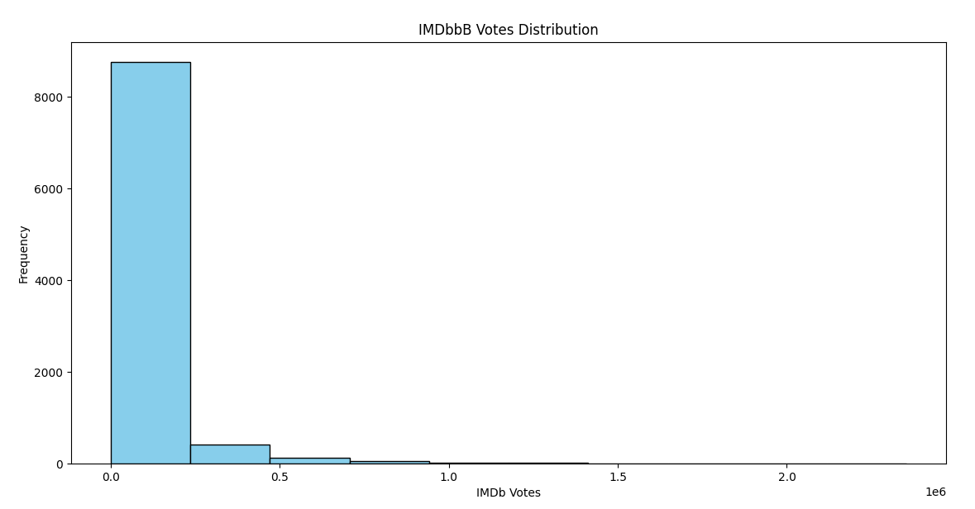
- Counts of Genre(s) of the films. The drama and comedy are the highest in all the categories. 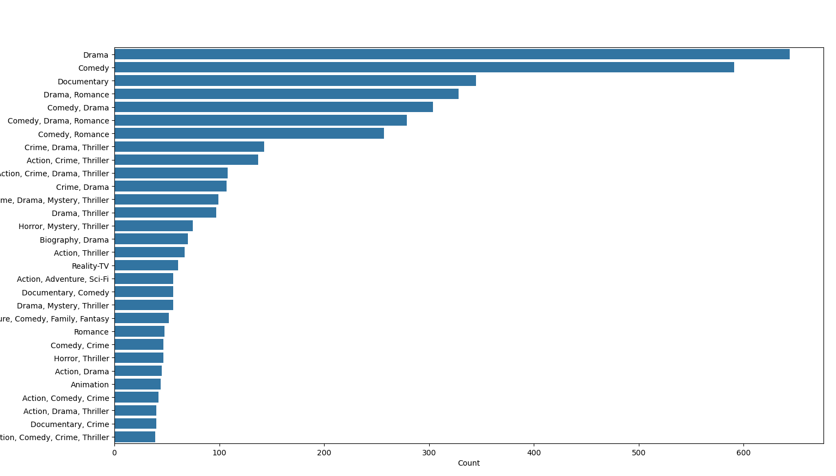
- Counts of language(s) of the film. As usual, English movies stand out to be the highest of all the categories.
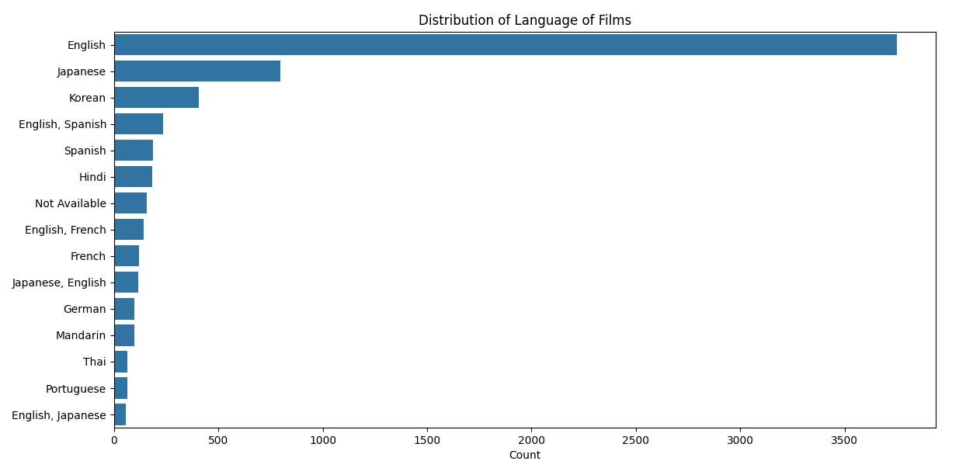
- Modeling: Following steps were performed as part of modeling:
- Most categories in this labeled dataset were “categorial data”. The Python module sklearn.neighbors does not work on categorial data and hence, as a first step, we had to transform the categorical data into the numeric data using ColumnTransformer() method.
- Divided the entire dataset into training and testing set into 8:2 ratio.
- Created a model using KNeighborsClassifer() method. Range of k from 0 to 10 and all four times of algorithms (kd tree, ball tree, brute force, auto) have been experimented for performance of the model.
- Fit the model using training dataset.

- Evaluation & Testing:
- The model was evaluated by introducing different values of k from the range of 0 to 10 and all four types of KNN algorithms (kd tree, ball tree, brute force, auto).
- For the testing, a User Interface (UI) was created where two inputs from two different users are allowed to be entered in the form of their preferred movies. Here’s a snippet of the UI:


Result Analysis
The model accuracy and precision were measured for all four types of KNN algorithm and for different values of k (0 to 10). Here are the results:
For “Kd Tree”:
Value of k | Accuracy | Precision
1 | 0.680489102 | 0.584795322
2 | 0.340244551 | 0.283537126
3 | 0.170122275 | 0.138224349
4 | 0.085061138 | 0.053163211
5 | 0.042530569 | 0.01772107
6 | 0.042530569 | 0.01772107
7 | 0.042530569 | 0.015948963
8 | 0.042530569 | 0.015948963
9 | 0.042530569 | 0.015948963
10 | 0.042530569 | 0.015948963

For “Brute Force”:
Value of k | Accuracy | Precision
1 | 0.850611377 | 0.765550239
2 | 0.404040404 | 0.347332979
3 | 0.255183413 | 0.184299132
4 | 0.148856991 | 0.109870636
5 | 0.148856991 | 0.102782208
6 | 0.127591707 | 0.081516924
7 | 0.127591707 | 0.079744817
8 | 0.106326422 | 0.081516924
9 | 0.085061138 | 0.070884281
10 | 0.063795853 | 0.053163211

For “Ball Tree”:
Value of k | Accuracy | Precision
1 | 0.963264221 | 0.989544568
2 | 0.404040404 | 0.30480241
3 | 0.212652844 | 0.10936432
4 | 0.212652844 | 0.10936432
5 | 0.212652844 | 0.105820106
6 | 0.212652844 | 0.098731678
7 | 0.212652844 | 0.089871143
8 | 0.212652844 | 0.09164325
9 | 0.19138756 | 0.095187464
10 | 0.148856991 | 0.051593631

For “auto”:
Value of k | Accuracy | Precision
1 | 0.786815524 | 0.719475456
2 | 0.38277512 | 0.317207159
3 | 0.212652844 | 0.185007974
4 | 0.148856991 | 0.131135921
5 | 0.127591707 | 0.116959064
6 | 0.127591707 | 0.09569378
7 | 0.106326422 | 0.063795853
8 | 0.085061138 | 0.049618997
9 | 0.063795853 | 0.028353713
10 | 0.063795853 | 0.024809498

Result Analysis:
- The accuracy and precision of the model decrease with the increase of the nos. of neighbors (k). This is obvious as k increases, the distance also increases and chances of getting neighbors which have similar density or class are lesser.
- The best accuracy and precision are achieved with k = 1 but using that value defeats the whole purpose of movie recommendation system as this system would suggest multiple movies to the user so that they have an option to select from.
- With the dataset used in this experiment, the best result is achieved with the “Ball Tree” algorithm.
- In general, the accuracy and precision of the model is poor. The main reason behind it is because of the categorical data. When the categorical data is converted to the numerical data, it loses precision, leads to increasing number of independent variables and potential chances of overfitting.

Challenges
Following challenges were observed during the course of this experiment:
- Since most of the dataset categories are categorical variables, they are needed to be transformed into a series of numeric variables using an encoding method. This leads to poor performance of the model and there is no way to improve it.
- The dataset that was used has many independent variables and hence, the model became too complex and resource intensive.

Further Improvement Ideas
Several new ideas can be applied to make this system better performing one. Highlighted ones are:
- KNN is pretty slow algorithm. Other methods like DNN (deep neural network) can be used to improve the efficiency of the model. Potentially, a hybrid system with different methods (e.g., DNN with KNN or DNN with GA (genetic algo)) can bring a better result.
- Instead of content-based system, a collaborative based system would bring a better result since that’s purely based on user’s preferences and experience.
- Different transformation methods and encoders can be tried out to enhance the transformation of categorical data to binary data.
- CPU resource usage should be measured and compared against the performance of other algorithms to solve the same problem.

Resources and References
- https://medium.com/@thakuravi2093/movie-recommendation-system-using-knn-and-tf-idf-7abeb522174c
- https://realpython.com/knn-python/
- https://www.kaggle.com/code/ibtesama/getting-started-with-a-movie-recommendation-system#Content-Based-Filtering
- https://towardsdatascience.com/prototyping-a-recommender-system-step-by-step-part-1-knn-item-based-collaborative-filtering-637969614ea
- https://pub.towardsai.net/a-movie-recommendation-system-using-nearest-neighbours-and-tensorflow-e41366672cd6
- https://www.analyticsvidhya.com/blog/2022/03/eda-and-recommendation-system-using-the-big-bang-theory-show-dataset/
- https://www.researchgate.net/publication/373343136_Algorithm_Improvement_of_Movie_Recommendation_System_based_on_Hybrid_Recommendation_Algorithm#fullTextFileContent
- https://medium.com/machine-learning-researcher/k-nearest-neighbors-in-machine-learning-e794014abd2a

